CT ID | Click or tap here to enter text.
Household Support Grant - Hampshire
CARERS REFERRAL FORM - Grants and Vouchers
Name | Click or tap here to enter text.
Contact | Click or tap here to enter text.
Organisation | Click or tap here to enter text.
Section One - for completion by: Andover MIND / Carers Together Hampshire / Princess Royal Trust for Carers Hampshire or other organization referring to these carer support organisations e.g. Adults’ Health and Care (AHC) Practitioner or other partner.

If AHC or other partner: Complete section one to refer to any of the above carer support organisations; email form or phone them with the corresponding details, they will then follow-up re. section two. Ensure you follow your organisation’s consent and data sharing protocols when making a referral.
Carer Name |  | Click or tap here to enter text.
Address |  | Click or tap here to enter text.
Postcode |  | Click or tap here to enter text.
Telephone |  | Click or tap here to enter text. | Mobile | Click or tap here to enter text.
Email |  | Click or tap here to enter text.
Gender of carer |  | Click or tap here to enter text. | Ethnicity of carer | Click or tap here to enter text.
Carer Age Range (Range or figure) |  | Click or tap here to enter text. | Number of people carer is looking after | Click or tap here to enter text.
Primary need of cared-for person(s) |  | Click or tap here to enter text.
Name of cared-for person(s) |  | Click or tap here to enter text.
Address of cared-for person(s) |  | Click or tap here to enter text.
Age of cared-for person(s) |  | Click or tap here to enter text.
Gender of cared-for person(s) |  | Click or tap here to enter text. | Ethnicity of cared-for person(s) | Click or tap here to enter text.
Reason for referral (please include whether referral is for a supermarket voucher OR for other items paid for directly from carers organisation)
Click or tap here to enter text.

Section Two – to be completed by organisation issuing the funds (Andover MIND / Carers Together in Hampshire / Princess Royal Trust for Carers Hampshire) Please indicate below which option you are using:

Supermarket voucher | Click or tap here to enter text.
Other Items | Click or tap here to enter text.

Section Three – if using Supermarket Voucher
Any previous vouchers received via this source of funding? |  |  | Click or tap here to enter text.
Choice of supermarket (from list in the voucher system) |  |  | Choose an item.
Voucher Amount | Click or tap here to enter text.
Date Issued | Click or tap here to enter text.
Issued by Name | Click or tap here to enter text.
Section Four – If other items have been selected, please detail the value and a brief description of the item(s)
Item(s) |  | Click or tap here to enter text.
Amount |  | Click or tap here to enter text.
Panel sign off (if over £500) |  | Click or tap here to enter text.

Organisational Contact Details:

- Andover MIND
Tel: 01264 332297 Email: enquiries@andovermind.org.uk

- Carers Together Hampshire
Tel: 01794 519495 Email: support@carerstogether.org.uk

- Princess Royal Trust for Carers Hampshire
Tel: 01264 835246 Email: Info@carercentre.com

Supermarkets who are participants in the voucher scheme:
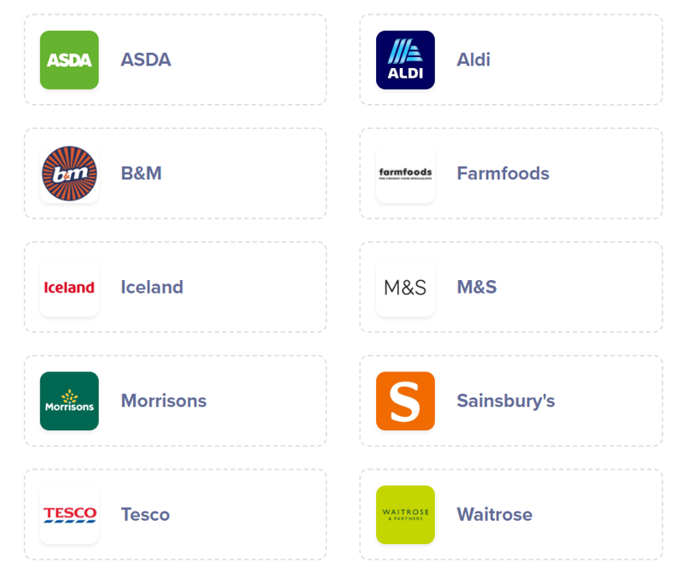
Note: Information accurate as of 20-12-22 – screenshot from voucher distribution website.

